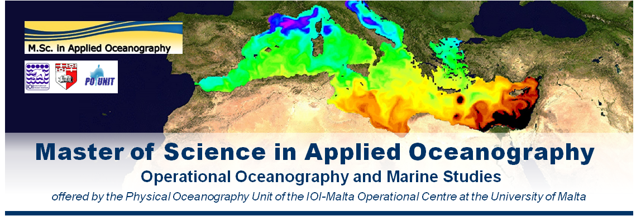
Scholarships for Master Course in Applied Oceanography (Malta)

The Physical Oceanography Unit of the IOI-Malta Operational Centre at the University of Malta is offering a new Master course in Applied Oceanography. The course opens in October 2014. It will be held at the University of Malta and is open to both local and foreign students. The course is delivered with the participation of an international faculty including high profile experts in operational oceanography.

The course builds on the core principles of oceanography in coastal and open sea domains, with a focus on operational oceanography and the versatile and broad spectrum of disciplines and offshoot applications related to it. The main target of the course is to match the human resource needs in the evolving marine sector at local, European and global scales, providing professionals with wide ranging skills to exploit the outcomes of marine research and technology in favour of the competitiveness of the industry and service sectors. It is also set against a background of the rising industrialisation of seas and oceans with increasing human impact (such as from renewable energy provision, aggregate extraction, fishing and leisure industries) and the extended quest for achieving sustainable development by protecting the marine ecosystem, minimising the impacts of climate change, natural hazards and anthropogenic influences, whilst maximising benefits to society.

The course is intended to train post-graduate students and professionals on state-of-the-art methodologies and tools to measure, understand and predict the marine environment, and derive sustained benefits from the sea. It is elaborated over a course programme spanning and merging the scientific, technical and applicative aspects of oceanography to offer students a wide-ranging integrated approach, linking science to management, putting technology at the service of users and stakeholders, and providing tools and training for more efficient service oriented applications. Targeted areas of such applications include: environmental monitoring and surveillance, assessment and mitigation of risks, marine science-based policy development and strategic planning, climate change, sustainable resource exploitation, ocean governance, marine industries and service provision, and the overall empowerment of human resources to face current and emerging challenges in the marine domain.

While retaining the necessary scientific elements related to the acquisition and use of data and its transformation into knowledge, the course targets to put an emphasis on achievement of skills, and empower students to excel in performance on applications and operational practices.

For more information on the course please visit the dedicated webpage:
http://www.um.edu.mt/ioi-moc/msc

The University of Malta is offering 3 scholarships to support qualified students to follow the course. For more information on the scholarships please go to:
http://www.um.edu.mt/ioi-moc/msc/applying_for_scholarships
EMAIL CONTACT: Prof. Aldo Drago (aldo.drago@um.edu.mt) or ioi-moc@um.edu.mt

